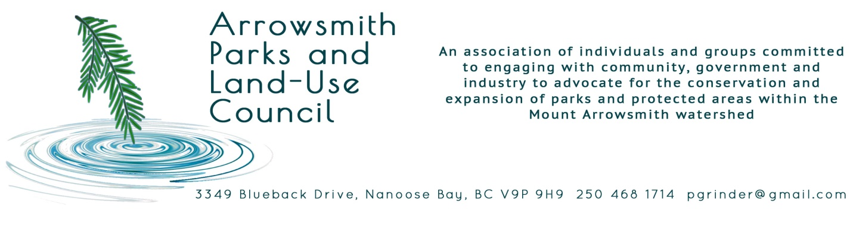

Larry Barr Feb. 1, 2019
Acting Regional Executive Director
West Coast Natural Resource Region
Ministry of Forests, Lands, Natural Resource Operations
and Rural Development

Mr. Barr;

Re: French Creek Watershed Protection.

Thank you for your letter of Dec. 27, 2018 in response to our letter Dec. 6th, 2018.

We are concerned that the acts and regulations you have cited will not offer sufficient guarantees of ecological or drinking water protection for French Creek.

For example, with respect to the Water Sustainability Act it is unclear who establishes and monitors “Critical Environmental Flows” in BC waters. Can you clarify this for us? Can you also identify what streams and rivers have had critical environmental flows established? We are aware that a critical environmental flow had been set for French Creek some years ago (as described in a provincial document titled: “French Creek Watershed Study”), and that summer flows are typically below what has been set as a critical environmental flow volume. Although this environmental flow was established by an outdated method, we are nonetheless alarmed by this and we fear that logging in the upper watershed could exacerbate the low flow problem.

Suggestion: French Creek flow monitoring should be implemented at a site immediately below the logging property so that specific effects of logging and other land altering activities can be identified. The installation of an automatic flow data logger at this location would make this task a relatively simple one. However, this activity is outside the scope and authority of APLUC and we seek your assistance in making this happen.

It seems that the Water Sustainability Act is concerned only with flows, and not water quality. Is this correct? Are there other provincial acts that deal with water quality for ecological protection? We’re certain that your ministry would agree that water quality is equally important as flows in ensuring the health of aquatic ecosystems.

We are aware of the work of the RDN’s Drinking Water and Watershed Protection Program in monitoring water quality in various rivers and streams in this part of Vancouver Island. Indeed, two of our affiliate organizations currently participate in this program by taking measurements and collecting water samples. However, this monitoring program may not be thorough enough to measure the specific effects of logging and other land altering activities in the upper watershed.

Suggestion: We ask the provincial government to work with the RDN in establishing a water quality monitoring station immediately downstream of the logging property, to measure logging effects on French Creek water quality. Monitoring should include a base-line condition (although some logging has already occurred), and frequent sampling for those parameters usually associated with logging. This would extend the scope of the DWWP Program.

We agree that ever-increasing demand for domestic and probably agricultural uses has decreased ground water aquifer levels within the French Creek watershed. This only heightens our concern that the French Creek flow regime may be altered by logging activities and thereby exacerbating this ground water problem for both domestic well uses and ultimately aquatic ecosystems.

Although the French Creek watershed has been designated as a “Community Watershed”, we are uncertain what particular protection measures are accorded to such watersheds. For example, does this designation provide for community input to resource extraction planning, such as logging? Should it? From a provincial regulation perspective, does this designation require a particular degree of caution in government decisions regarding the watersheds? For example, does it promote an enhanced interministerial exchange or referral of resource applications? Should it?

We are aware of the 2007 BC Supreme Court judgement against the Sunshine Coast Regional District which had sought a logging moratorium in its “Community Watershed” – Chapman Creek. We have made a similar suggestion for French Creek (see our earlier letter). But, if moratoria are not acceptable to the provincial government or the courts, what other avenues are open to communities or citizens who wish to protect their drinking water and ecosystems other than the Acts and regulations cited in your letter?

We note that the Sunshine Coast Regional District used measures in the provincial Health Act in their argument; which to the average citizen should be a strong enough instrument to use in advocating for watershed protection. Apparently not, although it seems an appeal to this ruling may be underway by the Regional District.

In a special investigation of community watersheds by the Forest Practices Board in 2014, deficiencies were found in both the management and assessment of these watersheds. Recommendations were made to, among other things, establish guidelines for an appropriate hydrologic assessment. We discovered a few weeks ago that the Association of BC Forest Professionals and the Engineers and Geoscientists of BC have prepared a draft set of guidelines titled: “Draft Professional Practice Guidelines: Watershed Assessment and Management of Hydrologic and Geomorphic Risk in the Forest Sector”, which we understand is in its final review. As far as we are aware the last hydrologic assessment of French Creek was done 18 years ago and may no longer be valid, given the number of changes in the watershed, global warming effects, etc. We have been advised that at least the larger forest companies commonly conduct hydrologic assessments, as has the company carrying out logging in the upper French Creek watershed, but this may be oriented more towards engineering requirements for such things as designing culvert sizes, than for an understanding of potential ecological effects or impacts on drinking water supply.

We would welcome your comments on our suggestions and views.

Respectfully,

Ross Peterson, on behalf of APLUC

cc. Honourable Doug Donaldson, Minister of Forest, Lands, Natural Resource Operations
and Rural Development.
Honourable John Horgan, Premier of B.C.

