Election fraud cannot go unchallenged. Support the Council in legal actions now underway to restore voters’ rights and the integrity of Canadian democracy. Donate now to the Democracy 24-7 Legal Fund.

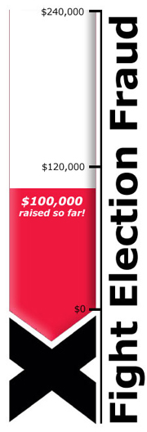
Mark your calendars. June 25, 2012 will be an historic day in Canada.
That's when the first step will be taken towards bringing justice to all Canadians who were the victims of election fraud around the 2011 federal election.
The Federal Court of Canada will begin hearing preliminary motions on the legal applications of nine individual Canadians to overturn the election results in seven federal ridings under The Canada Elections Act.
These motions include a classic divert and defame strategy by lawyers for the Conservative Party of Canada to have the cases tossed out before the Federal Court even has the opportunity to consider the powerful evidence supporting them.
The nine applicants have now served their submissions, which vigorously reject the CPC motions. These cite cases involving groups as diverse as the (American) National Association for the Advancement of Colored People and Canada's National Citizens' Coalition (N.C.C.): "There is some irony to this attack on the Council of Canadians for supporting litigation, which the N.C.C. has done for years, because at one time the N.C.C. was headed by the current Prime Minister."
The applicants' motions also include an affidavit from Nathalie Des Rosiers, General Counsel of the Canadian Civil Liberties Association, which states, "If the rights provided to electors under the [Canada Elections] Act are not to remain sterile and unused, it is essential that funding be obtained from third parties."
Friend, as we enter this crucial next stage to legally restore the democratic rights of Canadians I want to once again offer my deepest thanks to you.
Public donations to the Democracy 24-7 Legal Fund have been crucial to ensuring this has reached the Federal Court.
On June 25th, you and every person who believes in the fundamental right to vote will be with us in that courtroom.
With thanks,
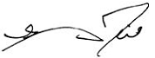
Garry Neil
Executive Director, The Council of Canadians
Help spread the word! Forward this email on to family and friends. Share the link to the Council's election fraud webpage (www.canadians.org/democracy247) on Facebook and tweet why this is important to you using the hashtag #Democracy247.
Donations can be mailed to: The Council of Canadians, 700-170 Laurier Ave W, Ottawa, ON K1P 5V5
Memo: Democracy 24-7
Phone: 1-800-387-7177
The Council of Canadians does not accept government, corporate or political contributions. Our work is sustained by the volunteer energy and generosity of concerned individuals like you. Due to our strong advocacy role, the Canadian government does not consider the work of the Council of Canadians to be charitable in nature, so we cannot issue tax receipts for donations.

