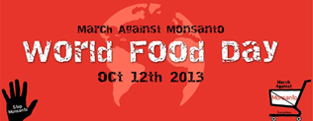

October 12th 2013 October 12th 2013 October 12th 2013 October 12th 2013 October 12th 2013
Thanksgiving Saturday(CAN) Thanksgiving Saturday(CAN) Thanksgiving Saturday(CAN) Thanksgiving Saturday(CAN) Thanksgiving Saturday(CAN)
March Against Monsanto March Against Monsanto March Against Monsanto March Against Monsanto March Against Monsanto
Global Food Day Global Food Day Global Food Day Global Food Day Global Food Day
Saskatoon 12:00 noon Saskatoon 12:00 noon Saskatoon 12:00 noon Saskatoon 12:00 noon Saskatoon 12:00 noon
Start @ Farmers Market Start @ Farmers Market Start @ Farmers Market Start @ Farmers Market Start @ Farmers Market
414 Ave. B South 414 Ave. B South 414 Ave. B South 414 Ave. B South 414 Ave. B South

End @ U of S End @ U of S End @ U of S End @ U of S End @ U of S

People Around The World People Around The World People Around The World People Around The World People Around The World
Unite! Unite! Unite! Unite! Unite!

